The Friends of the Plantation Library and
The Plantation Historical Society
present

International Book Award Winning Author
KB Schaller
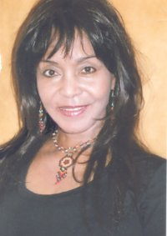
discussing her book 100 + Native American Women Who Changed the World

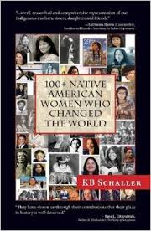

Saturday, November 15, 2014
2-3 pm
Helen B. Hoffman Plantation Library
501 N. Fig Tree Lane
Plantation, FL 33317
954-797-2140

Admission: FREE
Book will be available for purchase

