CONSOLIDATION PROPOSAL
JULIAN FIRE DEPARTMENT WITH
SAN DIEGO COUNTY FIRE

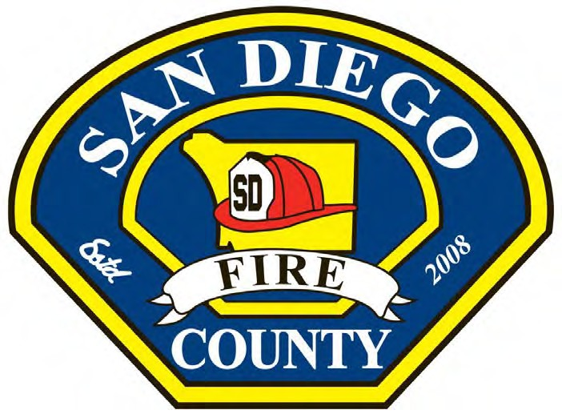

PREPARED BY:
HERMAN REDDICK, SAN DIEGO COUNTY FIRE PROGRAM MANAGER
TONY MECHAM, SAN DIEGO COUNTY FIRE CHIEF
OVERVIEW
As the demand and cost of providing Fire Protection and Emergency Medical Services increases, the Julian Fire District is looking at alternatives to provide a level of service that is both needed and expected by the Community.
San Diego County Fire (SDF) and the Julian Cuyamaca Fire Protection District (JCFPD) have agreed to enter discussions regarding the possible dissolution of the Fire District and the transfer of latent powers for fire suppression and emergency medical services from JCFPD to San Diego County Fire and CSA-135.
BACKGROUND
In 1978 following the passage of Proposition 13 the County of San Diego discontinued providing financial support for fire protection in the unincorporated portions of San Diego County. As a result, many local communities formed volunteer fire companies or fire protection districts. In 1984, the Julian and Cuyamaca Volunteer Fire Companies were consolidated into the Julian Cuyamaca Fire Protection District. The District is staffed by volunteer firefighters and a part time fire chief and operates two fire stations. The County of San Diego Emergency Medical Services Agency contracts with and subsidizes the JCFPD to provide Advanced Life Support Ambulance Services.
Since 2015, the District has publicly voiced concerns regarding their ability to fully fund the fire and emergency medical services, the Board of Directors formed an ad hoc committee and began discussions with the County of San Diego. In 2015, at the request of JCFPD the County and JCFPD signed a Contract for Service with the County to provide a Paramedic Fire Engine in Julian, a BLS Fire Engine in Cuyamaca and a variety of other services. A condition of the contract was that prior to December 31, 2017 the District must submit a dissolution application to LAFCO or all County subsidy would end on January 1, 2018.
No one questions the dedication and commitment of the JCFPD volunteer firefighters or the strong support demonstrated by the Community. However, as the demand and cost for fire protection and EMS services continue to increase along with increased training requirements and regulations, the JCFPD has struggled to maintain adequate staffing, including paramedic fire engines. Call volume has risen by 34% since 2013. The overall costs and long term liabilities associated with these services continue to rise with the number of emergency incidents within the District’s service area. The Julian Fire Department has no full time staffing other than the ambulance which serves a much larger geographic area, yet the demand for service has increased 5% - 7% annually. The District must address issues such as adequate staffing, replacement of fire apparatus and equipment and the likelihood of needing to add a 2nd Paramedic Ambulance. The ambulance is currently only meeting their contracted response times 76% when the County requires 90%.
The cost to provide these services has rapidly outpaced the growth in revenues forcing to the District to consider three options:
- Do nothing and maintain the status quo
- Ask residents to tax themselves $350-$400 dollars more annually to fund an equivalent level of services as offered by the County.
- Dissolve into County Service Area 135
In 2008, following a lengthy study conducted by the San Diego Local Agency Formation Commission, the County of San Diego Board of Supervisors adopted the Hybrid Plan. The Hybrid plan created a legal entity (County Service Area 135) that is responsible for fire protection and emergency medical services. The San Diego County Fire Authority was created to serve CSA 135. Through CSA 135, the County of San Diego is now required to provide fire protection and emergency medical services to over 1.5 million acres of unincorporated land. County Fire has adopted the mission of coordinating, regionalizing, and improving fire protection and emergency response services provided by State, local Career, and local Volunteer Reserve Firefighters in the unincorporated areas of the County by creating a comprehensive, regional, fire protection system. As part of this regionalization, all previous County Service Areas, Volunteer Fire Departments, and the San Diego Rural and Pine Valley Fire Protection Districts were consolidated into County Fire. San Diego County Fire currently staffs 33 fire stations daily with 17 Basic Life Support Engine Companies, 14 Paramedic Fire Engines, and 2 Paramedic Truck Companies along with a full complement of support services (Fire Prevention, EMS, GIS, Logistics, Fleet Services, Finance, Procurement, Volunteer Reserve Coordinator, Facility Maintenance, Strategic Planning and more).
San Diego County Fire has received an ISO rating of 3/3X ISO for their service area which is a clear indicator of the success of this regional approach.
Consolidating the service area of the District for fire suppression and emergency medical services is consistent with the mission of San Diego County Fire.
ISSUE
A long-term look to the future indicates that the service demand and cost to provide service in Julian will continue to outpace the growth in revenue. With benefit fees capped and no new sources of revenue, the District must consider alternatives. A lack of service level improvements could have compounding effects as the District is currently not meeting the County Contracted Response Time Standard of 90% for Paramedic Service. Local and National trends indicated the call volume in Julian will increase 5% to 7% annually over the next 10 years. With the continued demand for services, along with general operating cost increases, the District is at a crossroads of providing service and controlling costs.
FINANCIAL
The Julian Cuyamaca Fire Protection District operates with a Budget of $432,000 of which $78,000 is provided by the County of San Diego. In FY 16/17, the District is proposing to transfer $44,000 to Reserves. With the loss of the County Subsidy the District will be operating with a negative balance of $34,000. The ambulance budget is $474,000 of which $130,000 a subsidy from the County. For FY 16/17, the ambulance service is projected to be operating in the negative by $14,500.
The County of San Diego is currently providing $1,591,140 in funding consisting of:
- $1,205,406 Paramedic Fire Engine in Julian
- $253,734 Winter Fire Engine Coverage in Cuyamaca
- $78,000 Direct Subsidy
- $15,000 Dispatching Costs (500 Calls at $30.00 per call)
- $15,000 Fire Prevention Fees (Estimate)
- $24,000 Vehicle Maintenance and Operation (ME-50, WT-56, E-3355)
CONCEPT
The County of San Diego believes that regionalizing and consolidating fire services is the best long term strategy for the provision of services in the unincorporated areas of the County. Regionalization provides a greater depth of resources and a lowering of costs by avoiding costly duplication of service and sharing of critically needed support services. San Diego County is proposing to assume the responsibility for Fire and EMS services in the District with significant increases in service including 24x7 career staffing at fire stations in both Julian and Cuyamaca. Furthermore, the County is proposing to assume and maintain a volunteer firefighter program in Julian and move a medium rescue/light and air apparatus into the district. The County and District would negotiate a transfer of property, assets, debts and revenue from the District to County Fire. The current Fire Chief will become a part time temporary employee of the County to help guide the transition and the Board of Directors will serve on the San Diego County Fire Advisory Committee representing Julian.
This process would take approximately 12 months.
Upon transfer of authority, San Diego County Fire will be responsible for:
- Fire suppression and emergency medical services within the service area
- Maintenance, repair, and replacement of all apparatus required for the service area
- Maintenance, repair, and replacement of all equipment required for the apparatus
- Maintenance, repair, and replacement of all fire facilities within the service area
- Maintenance, repair, and replacement of all furniture, fixtures, and equipment required for the facilities
- Providing fuel for all fire apparatus and utilities for all fire facilities
- Providing a discretionary fire station operations budget
- Information Technology and Radio System Operations
- RCS Radio repair and replacement
- Maintain an ALS Engine at Julian Station 56
- Maintain year-round staffing at Cuyamaca Station 51
- Provide Fire Prevention services
- Provide 9-1-1 Dispatching Services

