Julian Cuyamaca Fire Protection District
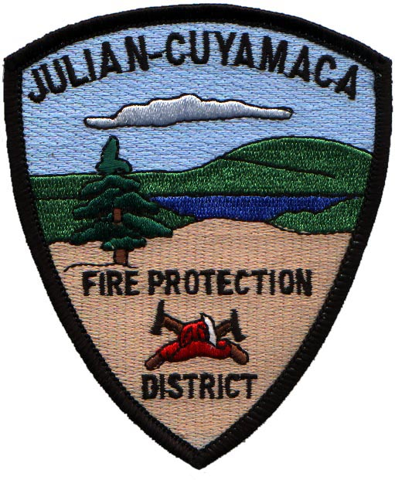

August 5, 2015

Julian Cuyamaca Functional Consolidation Concept Paper

Introduction

In recent weeks the Julian Cuyamaca Fire Protection District (JCFPD) Board of Directors (BOD) voted to form a committee to open negotiations with the San Diego County Fire Authority (SDCFA). The committee members consist of BOD President-Jack Shelver, BOD member-Aida Tucker, Community Member- Stacey Peyakov and JCFPD Chief-Rick Marinelli. The goal of the committee is to enter into a cooperative agreement with the SDCFA to enhance the Emergency Medical Service (EMS) and Fire Protection service in the Julian- Cuyamaca and San Diego County unincorporated area and enter into a functional consolidation between the JCPFD and SDCFA.

Situation Statement

The JCFPD was formed in 1983. The Julian and Cuyamaca Volunteer Fire Departments were merged into the JCFPD. The District was initially all volunteers until the BOD determined the need for a paid Fire Chief. Around the same time the JCFPD was awarded a contract with San Diego County to provide an Advanced Life Support (ALS) transport ambulance for the Julian Service Area. About one year ago the JCFPD was awarded a subsequent contract and has completed the first year of a three year contract with the possibility of four extensions of one year each. To date, the JCFPD employs three full time paramedics, three full time EMTs and a part time EMS Coordinator to staff the ambulance along with a part time District Secretary and part time Fire Chief. The rest of the JCFPD’s human resources are all volunteers.

The JCFPD also administratively employs 3-5 employees to assist the SDCFA and Cal Fire to staff the warehouse and other duties as assigned by those two agencies.

Furthermore, the SDCFA subsidizes the JCFPD and provides funding, dispatch service and Fire Marshall services to the JCFPD. In return the JCFPD staffs additional fire suppression resources at the request of the County and Cal Fire.

The JCFPD also has an automatic aid with Cal Fire for EMS and fire protection services in and adjacent to the boundaries of the JCFPD.

In recent years it has become apparent to the JCFPD of the need to provide additional staffing in the District. The volume of EMS calls has been increasing each year. Also, the wildland fire problem in San Diego County is increasing with no relief anticipated. In addition, the standard level of care in most of San Diego County has risen from basic life support (BLS) to ALS.

The JCFPD ambulance is the only ALS service provider in the Julian Cuyamaca Area. The ambulance service area is a much larger area than the JCFPD boundaries and the ambulance is routinely committed to ambulance transports and calls. During these periods the JCFPD is left covered only by volunteers and available Cal Fire resources, none of which are ALS equipped or qualified.

The JCFPD BOD recognized the need to provide additional paramedic ALS coverage in the Julian Cuyamaca area. In November 2014 a ballot initiative was introduced to raise the funding level to the JCFPD in order to hire paramedics and staff a medic (ALS) engine. The ballot initiative was not passed but did receive about 45 percent positive vote.

Currently

The committee and SDCFA/Cal Fire Unit Chief Mecham have met three times. Both entities agree there is a need to improve service in the JCFPD. Several options have been discussed. These options will enhance the overall goal to Regionalize EMS and Fire Protection in San Diego County and at the same time acknowledging individual community’s uniqueness.

The JCFPD would like to explore the possibilities of enhancing the current agreement with the SDCFA to include a County subsidized medic engine staffed 24/7 in the JCFPD. Also, further requests for serices would include, fleet maintenance and repair, County RCS access, maintenance and upgrades, access to SDCFA reserve firefighter program to enhance JCFPD staffing abilities, assign one SDCFA patrol unit to the JCFPD, and access to SDCFA logistical support.

The committee believes these improvements will move the JCFPD toward alignment with the concept of Regional Fire Protection and EMS.

Benefits

Although benefits of such an agreement can be described as what each agency will gain. The real benefit will be to the public we serve. Julian and surrounding area residents and visitors will have access to 24/7 ALS care and support, 24/7 fire protection service provided by a staffed medic engine. The community of Julian will retain their fire department and give volunteers a chance to serve their communities, not only in fire protection but other areas of community service like school demonstrations, fourth of July parade, CERT, fire safe council support, input and mitigation support for construction projects, and the ability to identify and meet the needs of the local community and accommodate the uniqueness of the Julian Cuyamaca Community. Also, having the JCFPD will allow for additional firefighters to staff JCFPD Fire Engines, Recues, Patrol Units, Water Tender Staffing and provide additional layer of fire fighter and duty officer coverage in the District.

The JCFPD will still exist to provide a highly reliable ambulance service to the County EMS program and maintain a functional community based volunteer fire program.

This concept of a functional consolidation will help achieve the goal of a Regional Fire Service and help to align the JCFPD with the overall goals of the SDCFA.

Important benefits also include enhanced relationships between the Community of Julian/Cuyamaca, San Diego County and Cal Fire. An increased level of commitment will increase the level of trust and credibility from all agencies and communities involved.

Proposal

The San Diego County Fire Authority would end the direct allocation of funds to the JCFPD and replace them with in kind services. Although many details need to be worked out, the following is our proposed concept.

- San Diego County would provide the following: Dispatch Services, Fire Marshall Services, Regional Communication System Services, Vehicle Maintenance, Fire and Rescue Apparatus Fuel, Misc. Personnel Protective Equipment and all costs for a SDCFA Reserve Program in Julian-Cuyamaca.

- San Diego County would staff a three person (two career and one reserve) staffed ALS Fire Engine at Julian Station 50.

- County would expand the Reserve Firefighter Program to include staffing at JCFPD and Cal Fire Stations as appropriate to achieve adequate staffing levels. Existing JCFPD Reserves would transition to Fire Authority Reserves.

- The JCFPD would be operationally integrated within the Fire Authority. This would include common training, closest resource concept and boundary drops, and standardized equipment.

- San Diego County will work to acquire a Type 6 patrol for Volunteer Reserve staffing within the JCFPD.

- Cuyamaca Station 51 would remain open as part of the County Amador Program.

- Existing Cal Fire Battalion Chiefs would augment 24/7 Chief Officer coverage for the District.

- JCFPD will retain a Fire Chief to serve as District Administrator.

- JCFPD would retain administration, oversight and financial responsibility for their facilities, ambulance program and volunteer firefighter program.

Chief’s Perspective

This concept can only enhance the service we provide to the public. The Regional Fire concept is something San Diego County has needed for decades and is finally here. But with all change there are growing pains. A one size fits all approach will not work. Special considerations must be acknowledged and accommodated if the Regional approach is going to be accepted. This concept is in alignment with various LAFCO, San Diego County and Grand Jury reports. The end result is what is important to stay focused on, not how we get there. To that end all agencies involved should seek creative ways to bring the highest level of fire protection and EMS to our County. This affects all members of the public, not just Julian.

As the Chief of the JCFPD, 35 year resident of Julian and 37 years of fire service experience in San Diego County I strongly endorse this concept and look forward to moving the JCFPD into a new era of Emergency Medical Service and Fire Protection, not because it will benefit me, the Julian Cuyamaca Fire Protection District or the San Diego County Fire Authority but because it is the right thing to do for the public we serve.

Sincerely,

Rick Marinelli
Chief - JCFPD

